**9-28-23 Notes**

A Deeper Dive into Python

Goals:

By the end of this lesson, you will be able to:

* Create and use data structures, including lists, tuples, and dictionaries.
* Create and use decision and repetition statements.
* Create and use Boolean and logical operators.
* Add, commit, and push code to GitHub from the command line.

Cereal Solution:

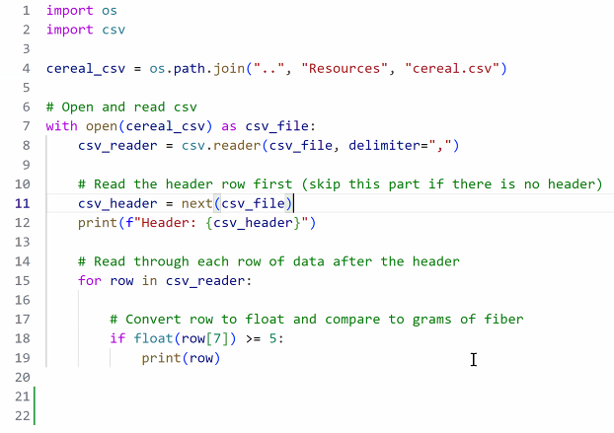

Generally, the line 1 and 2 say From (library) Import (file)

Line4- Pathing uses quotes around an item and commas in between. Not / like windows explorer

Can use “./cereal.csv” if it’s in the same folder

In VS code, if the absolute path has numbers at the start of folders, you have to use \\ instead of \

* Or you can flip the direction of the slashes from \ to /

Steps:

Get the file

Open the file

Read the file (stores the data in the local workspace for the code)

Line 11/12- Print Header

Lines 14-19- Calculations and Print results

**Dictionaries:**

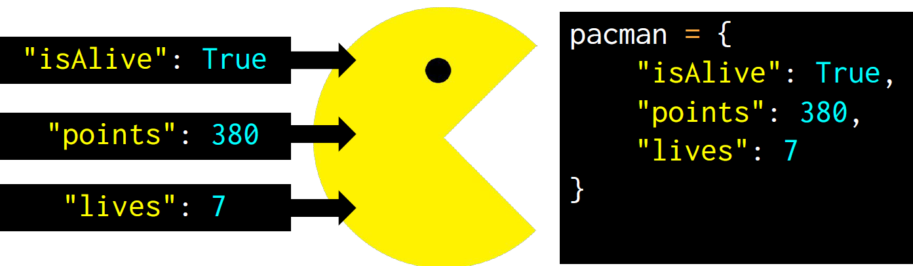

Yellow = Key

Value = Blue

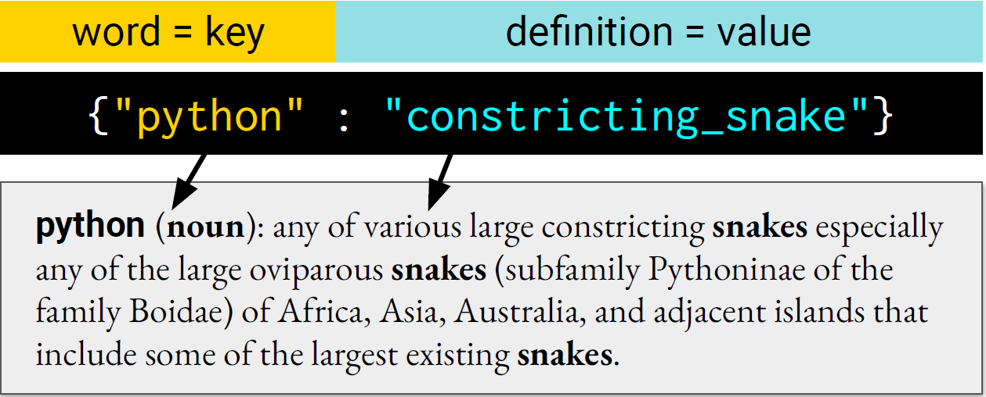

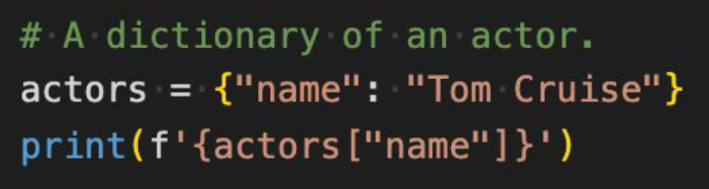

Call your dictionary {} and Add a record

Print any records in the dictionary that have the key you want (in this case, “name”)

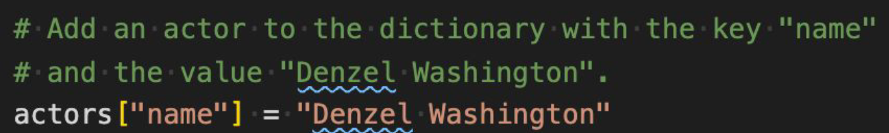

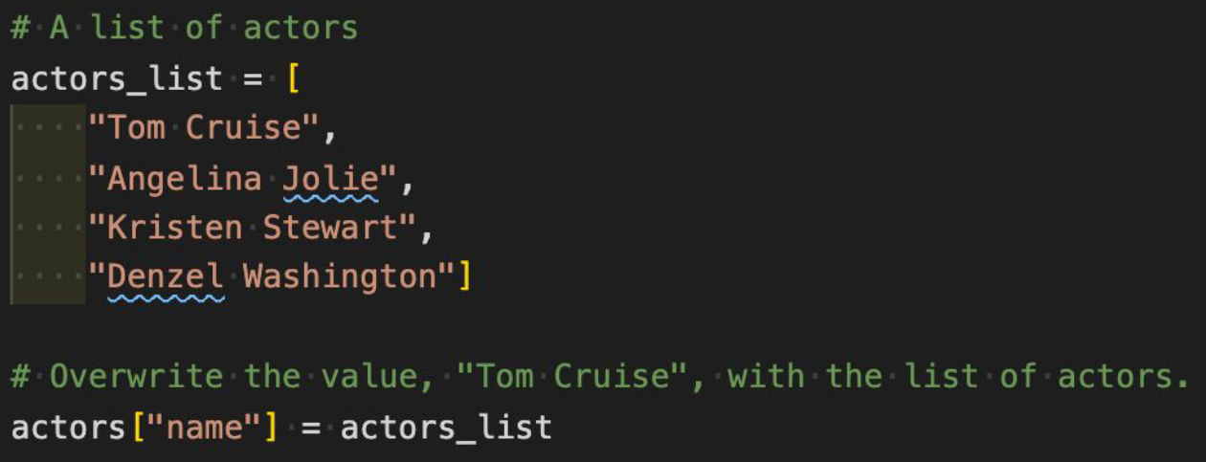

^Overwrite

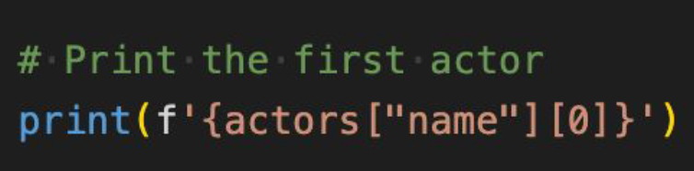

^Print a specific record

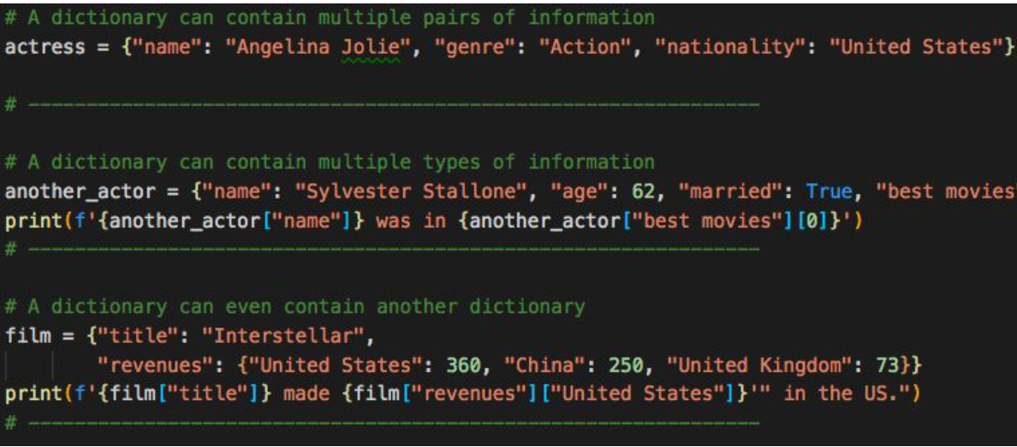

^Nested dictionary

**Dictionary example**

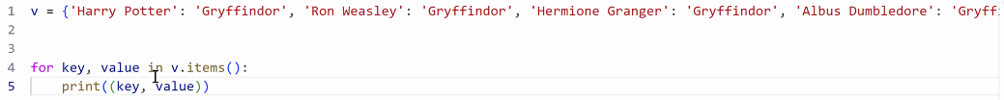

If you put in:



It’ll print the value associated with the key Ron Weasley

Results:

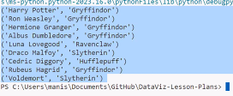

**Hobby Book:**

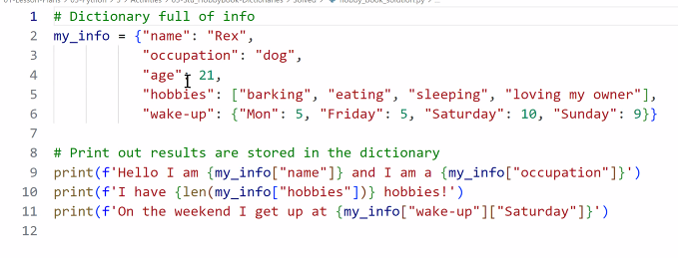

Results:



My_info is a dictionary

Line 6- Wake-up is also a dictionary

Line 10 prints “I have 4 hobbies!”. Everthing within {} is the calculation

Line 11- {my_info[“wake-up”][“Saturday”]} looks up

**List Comprehensions:**

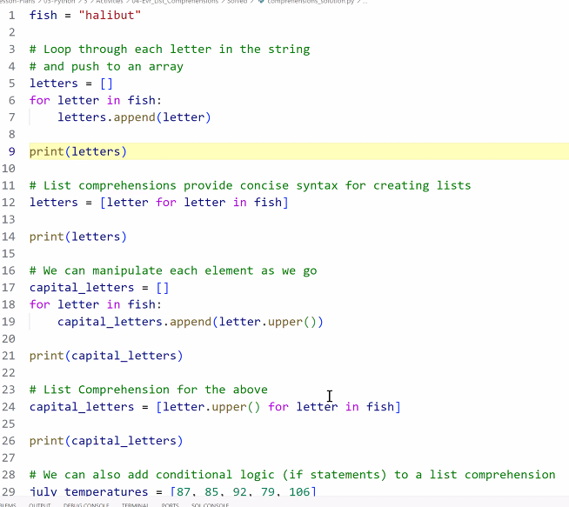

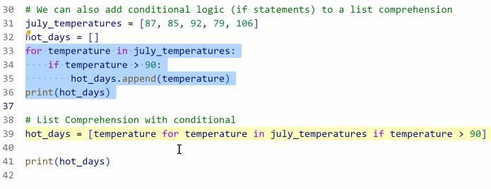

Line 12- Reinitializes the list letters. (clears it and resets it’s contents)

Lines 17-22 and 23-27 do the same thing

Lines 32 to 36 and line 39 do the same thing

**DEBUG MODE:**



Clicking to the left of the numbers makes a breakpoint. The code will run a step from the start to the end of the line where there’s a breakpoint.

Run folder in top bar, Start debugging

* F5 is the keyboard shortcut to start debugging (run the code from one breakpoint to another)

**List Comprehension practice (individual student activity):**

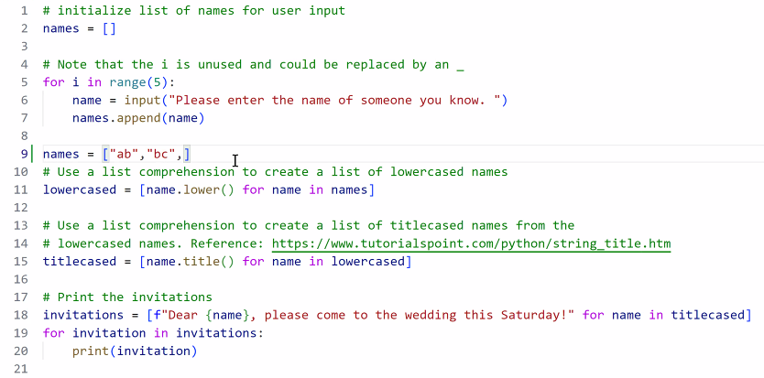

Titlecased names (line 15)- First letter is capitalized, remainder are lowercase.

**Writing functions:**

If you see the same code repeated over and over, you cold probably make it into a function and call the function as needed. This way, if you need to edit it, you only have to change it in one spot.

Review video around 8:38pm- If you put INT in, it’ll let you know what kind of data to put in the parentheses when you hover the mouse over the parentheses in the function

**Functions solution:**

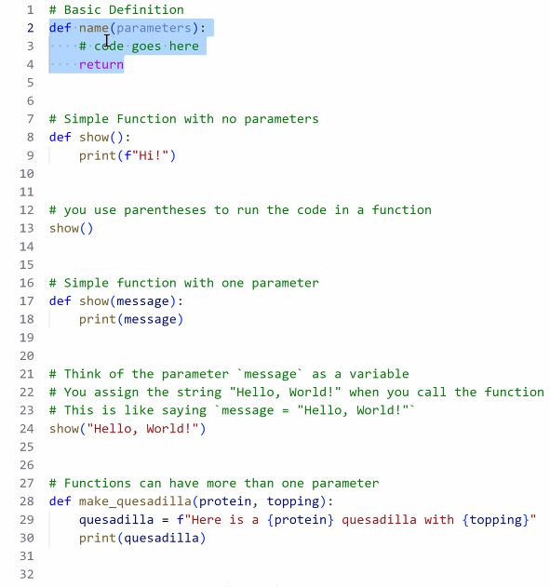

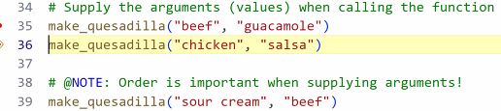

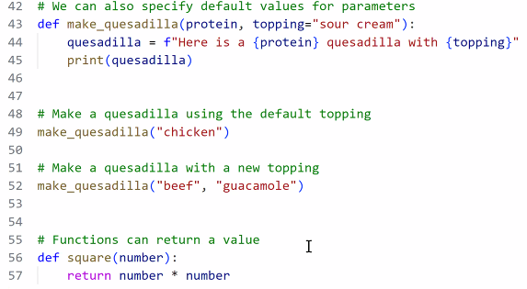

=+ equates to total +number



**Student Functions solution:**

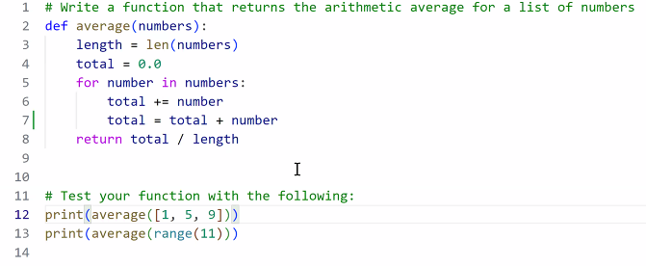

^ This is the #1 code to review in Debug mode in VS code.

Graduation functions activity solution:

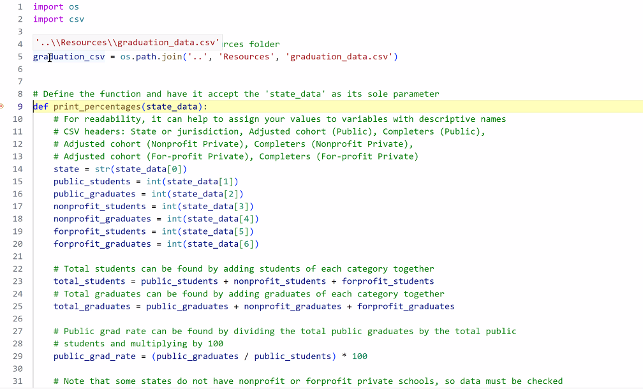

^Line 4 was added by Manish. Line 5 that the module provided isn’t working for Manish.

Screenshot below is with lines 10-64 collapsed.

Line 83 uses the PrintPercentage function that was written in the collapsed lines (10-64)

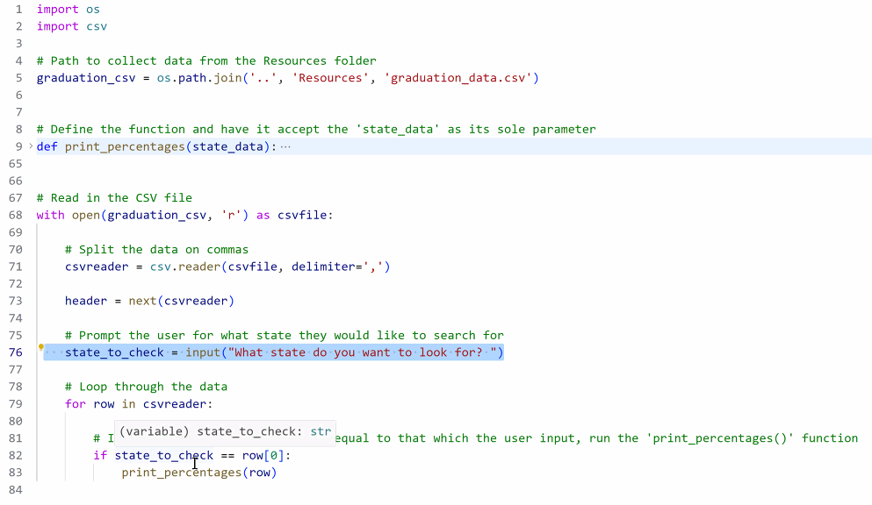

^ lines 65 onward is the 2nd part of the code after the function

VS Code can collapse a function using the tiny popup arrow to R of row number

